Session 5

Joins with CASE Statements
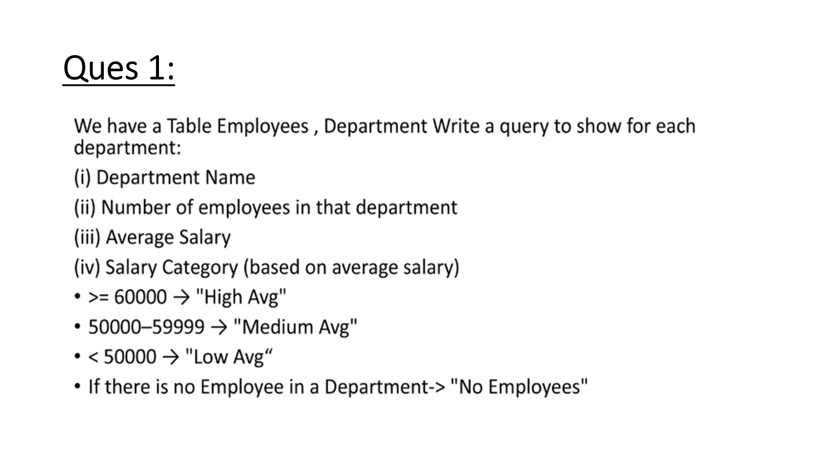
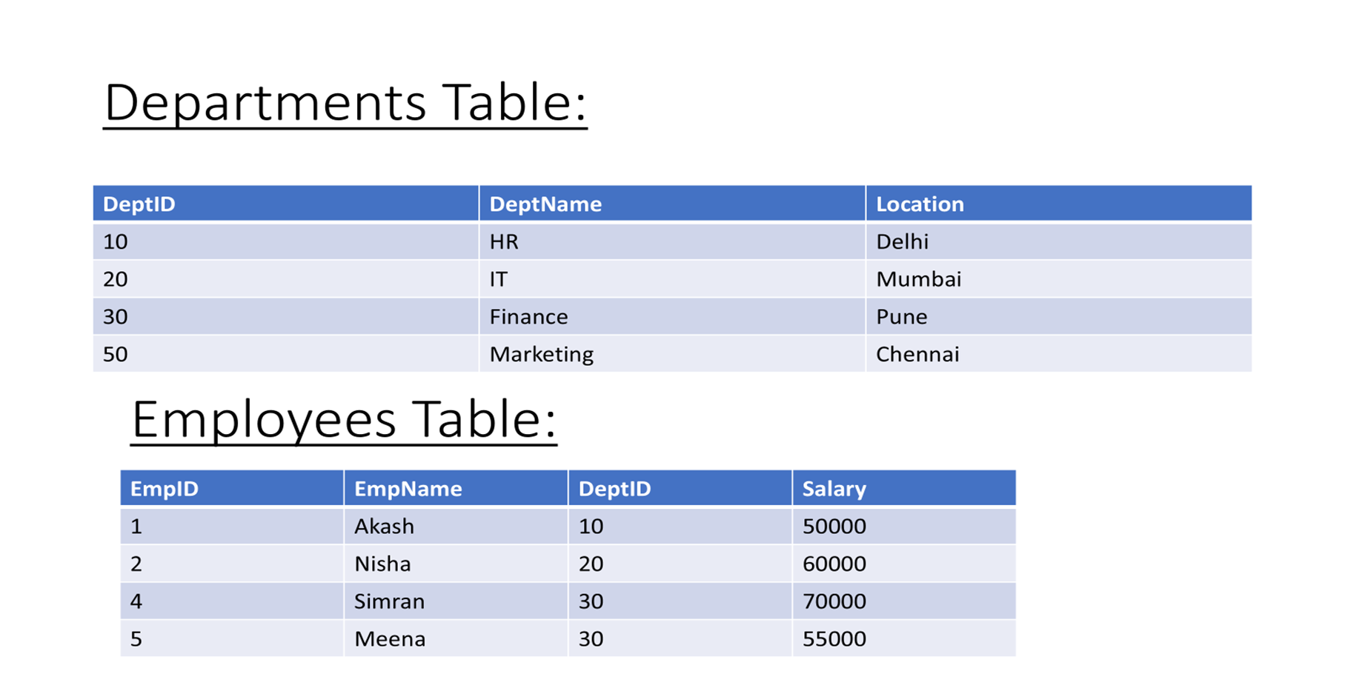
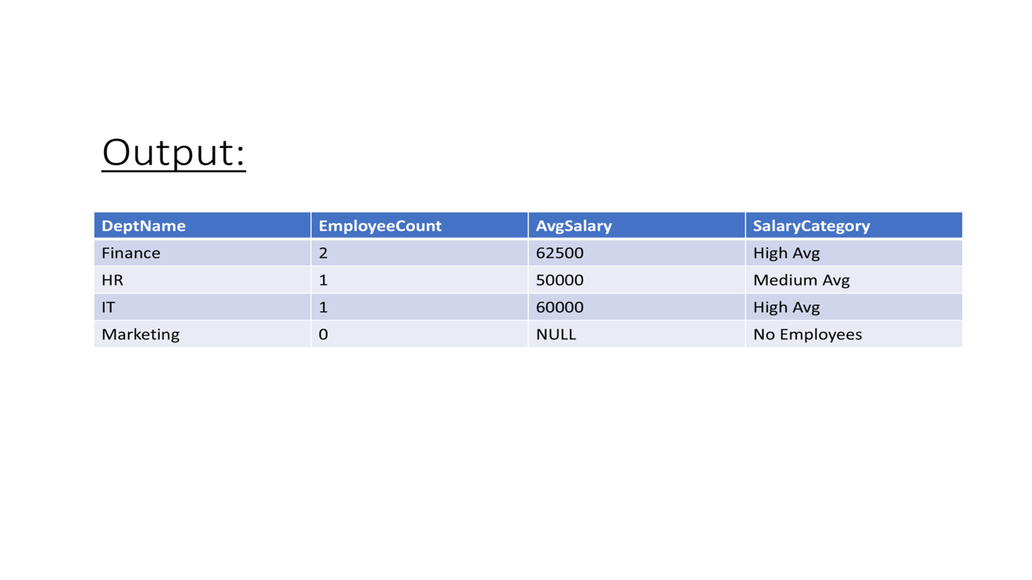

Solution:

CREATE TABLE Departments (
DeptID INT PRIMARY KEY,
DeptName VARCHAR(50),
Location VARCHAR(50)
);

CREATE TABLE Employees (
EmpID INT PRIMARY KEY,
EmpName VARCHAR(50),
DeptID INT,
Salary INT,
FOREIGN KEY (DeptID) REFERENCES Departments(DeptID)
);

INSERT INTO Departments (DeptID, DeptName, Location) VALUES
(10, 'HR', 'Delhi'),
(20, 'IT', 'Mumbai'),
(30, 'Finance', 'Pune'),
(50, 'Marketing', 'Chennai');

INSERT INTO Employees (EmpID, EmpName, DeptID, Salary) VALUES
(1, 'Akash', 10, 50000),
(2, 'Nisha', 20, 60000),
(4, 'Simran', 30, 70000),
(5, 'Meena', 30, 55000);

Approach 1:

SELECT
d.deptname AS department_name,
COUNT(e.empid) AS total_employees,
(AVG(e.salary)::Numeric(20)) AS average_salary,

CASE
WHEN COUNT(e.empid) = 0 THEN 'No Employees'
WHEN AVG(e.salary) >= 60000 THEN 'High Avg'
WHEN AVG(e.salary) BETWEEN 50000 AND 59999 THEN 'Medium Avg'
ELSE 'Low Avg'
END AS salary_category

FROM Departments d
LEFT JOIN Employees e
ON d.deptid = e.deptid

GROUP BY d.deptid, d.deptname

Approach 2

WITH dept_summary AS (
SELECT
d.deptid,
d.deptname,
COUNT(e.empid) AS total_employees,
AVG(e.salary)::Numeric(20,0) AS avg_salary
FROM Departments d
LEFT JOIN Employees e
ON d.deptid = e.deptid
GROUP BY d.deptid, d.deptname
)

SELECT
deptname AS department_name,
total_employees,
avg_salary AS average_salary,

CASE
WHEN total_employees = 0 THEN 'No Employees'
WHEN avg_salary >= 60000 THEN 'High Avg'
WHEN avg_salary BETWEEN 50000 AND 59999 THEN 'Medium Avg'
ELSE 'Low Avg'
END AS salary_category

FROM dept_summary

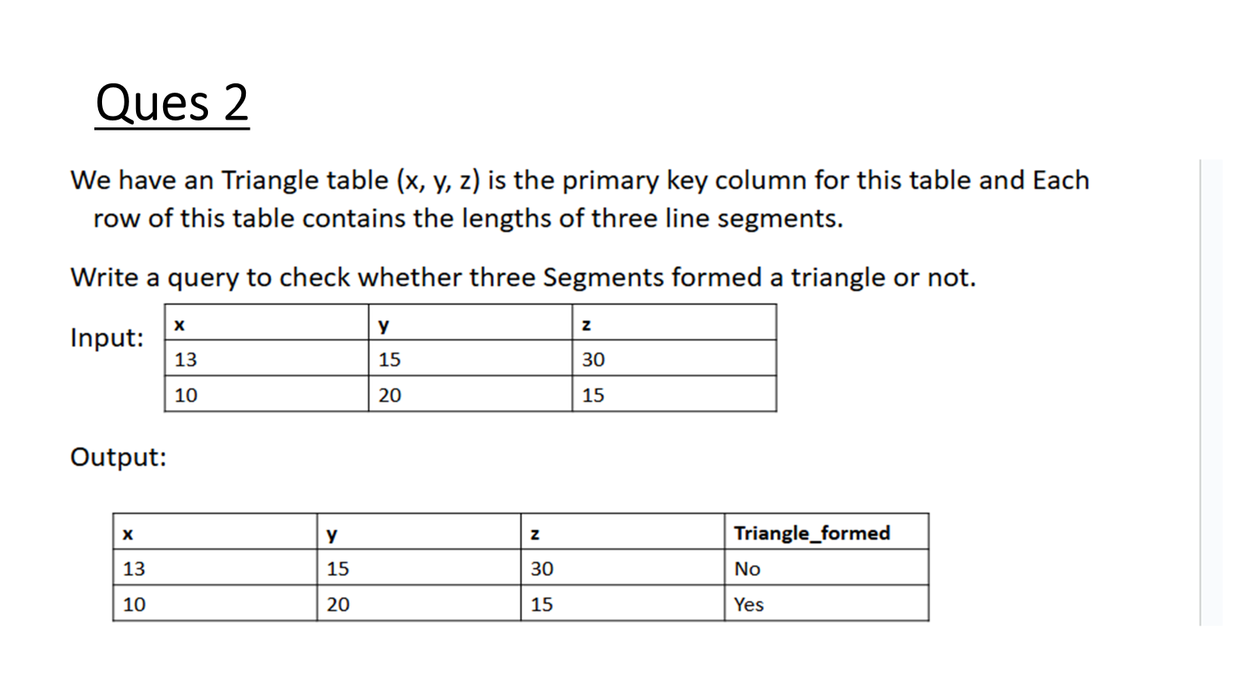

Solution:

-- Create Triangle table
CREATE TABLE Triangle (
x INT,
y INT,
z INT,
PRIMARY KEY (x, y, z)
);

-- Insert sample data
INSERT INTO Triangle (x, y, z) VALUES
(13, 15, 30),
(10, 20, 15);

Approach:

SELECT
x,
y,
z,
CASE
WHEN x + y > z
AND x + z > y
AND y + z > x
THEN 'Yes'
ELSE 'No'
END AS triangle
FROM Triangle;

